**ICT LAB**

**Lab # 01**

*BCS 1-J*

Roll no# 23k-2001

Name: M.Muzammil Siddiqui

**History of Computers**

The first counting device was used by the primitive people. They used sticks, stones and bones as counting tools. As human mind and technology improved with time more computing devices were developed.

The first computer:

Abacus:

The history of computer begins with the birth of abacus which is believed to be the first computer. It is said that Chinese invented Abacus around 4,000 years ago.

It was a wooden rack which has metal rods with beads mounted on them. The beads were moved by the abacus operator according to some rules to perform arithmetic calculations. Abacus is still used in some countries like China, Russia and Japan. An image of this tool is shown below;

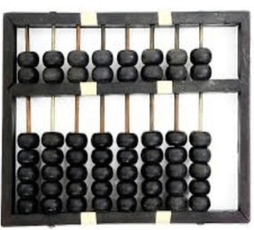

**Generations of Computers:**

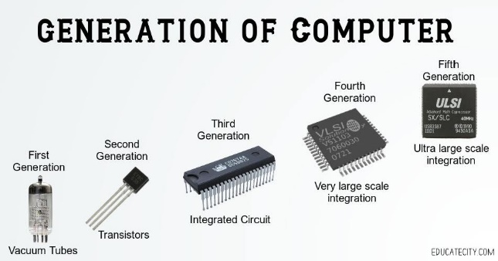A generation of computers refers to the specific improvements in computer technology with time. In each new generation, the circuits became smaller and more advanced than the previous generation circuits. The miniaturization helped increase the speed, memory and power of computers. There are five generations of computers which are described below:

***First generation of Computers:***

The first generation (1946-1959) computers were slow, huge and expensive. In these computers, *vacuum tubes* were used as the basic components of CPU and memory. These computers were mainly depended on batch operating system and punch cards. *Magnetic tape and paper tape* were used as output and input devices in this generation;

Examples include;

* **UNIVAC**( Universal Automatic Computer)
* **EDVAC** ( Electronic Discrete Variable Automatic Computer)
* **IBM-650**
* **ENIAC** ( Electronic Numerical Integrator and Computer)

***Second Generation of Computers:***

The second generation (1959-1965) was the era of the *transistor computers*. These computers used transistors which were cheap, compact and consuming less power. In this generation, *magnetic cores* were used as the primary memory and magnetic disc and tapes were used as the secondary storage. Assembly language and programming languages like *COBOL and FORTRAN*, and multiprogramming operating systems were used in these computers. Examples;

* **IBM 1620**
* **IBM 7094**
* **UNIVAC 1108**

***Third Generation of Computers:***

The third generation computers used *integrated circuits (ICs)* instead of transistors. A single IC can pack huge number of transistors which increased the power of a computer and reduced the cost. The computers also became more reliable, efficient and smaller in size. These generation computers used remote processing, time-sharing, multi programming as operating system.

Examples;

* **IBM-360 series**
* **Honeywell-6000 series**
* **IBM-370/168**

***Fourth Generation of Computers:***

The fourth generation (1971-1980) computers used *very large scale integrated (VLSI) circuits*; a chip containing millions of transistors and other circuit elements. These chips made this generation computers more compact, powerful, fast and affordable. These generation computers used real time, time sharing and distributed operating system. The programming languages like *C, C++, and DBASE* were also used in this generation.

Following are the examples of this generation:

* **DEC 10**
* **STAR 1000**
* **PDP 11**
* **CRAY-1(Super Computer)**
* **CRAY-X-MP(Super Computer)**

***Fifth Generation of Computers:***

In fifth generation (1980-till date) computers, the VLSI technology was replaced with *ULSI (Ultra Large Scale Integration)*. It made possible the production of *microprocessor chips* with ten million electronic components. This generation computers used *parallel processing hardware and AI* (Artificial Intelligence) software. The programming languages used in this generation were C, C++, Java, .Net, etc.

Examples include;

* **Desktop**
* **Laptop**
* **NoteBook**
* **UltraBook**
* **ChromeBook**

*Summarizing all the generations of computers we can refer to the following chart:*

